Temporary Strainers

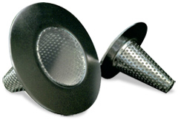

Application
- Oxford Filtration manufacture temporary basket strainers in all ratings and pipe sizes for virtually all fluid duties. Temporary strainers are designed to provide inexpensive protection for pumps, meters, valves and other equipment during commissioning and start up.
- Materials available as standard are carbon and stainless steel but other special alloys on request.
- Sizes from DN25 1" to DN600 24" are available in ratings from ANSI150 TO 2500lbs

Design
- Standard stocked design to detail dimensions as below.
- Designs to customers specification available on request.
- For sizes and pressure ratings not shown, contact our sales office.

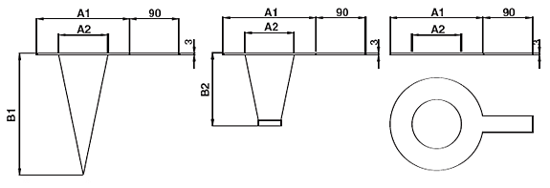

NB |  | 25 (1") | 40 (1.5") | 50 (2") | 80 (3") | 100 (4") | 150 (6") | 200 (8") | 250 (10") | 300 (12") | 350 (14") | 400 (16") | 450 (18") | 500 (20") | 600 (24")
A1 | 150 | 63 | 79 | 98 | 130 | 168 | 215 | 273 | 333 | 403 | 444 | 508 | 542 | 600 | 711
 | 300 | 69 | 88 | 104 | 142 | 174 | 244 | 301 | 355 | 415 | 479 | 533 | 590 | 674 | 768
 | 600 | 69 | 88 | 104 | 142 | 187 | 260 | 314 | 393 | 450 | 485 | 558 | 606 | 676 | 784
 | RTJ | 42 | 60 | 71 | 112 | 138 | 200 | 258 | 312 | 369 | 408 | 458 | 522 | 571 | 676
A2 |  | 22 | 31 | 44 | 67 | 88 | 139 | 181 | 228 | 276 | 320 | 368 | 415 | 466 | 568
A3 |  | 12 | 19 | 31 | 50 | 63 | 101 | 142 | 184 | 225 | 257 | 290 | 342 | 381 | 457
B1 | Conical  Regular | 38 | 101 | 114 | 165 | 215 | 330 | 431 | 533 | 635 | AVAILABLE ON  SPECIAL REQUEST ONLY
 | Conical  Long | 50 | 139 | 152 | 228 | 292 | 431 | 584 | 685 | 825
B2 | Basket  Regular | 38 | 63 | 83 | 88 | 114 | 165 | 215 | 254 | 304 | 330 | 355 | 381 | 431 | 508
 | Basket  Long | 50 | 88 | 88 | 114 | 152 | 228 | 304 | 355 | 419 | 431 | 482 | 533 | 609 | 711
KG |  | 0.5 | 0.75 | 0.75 | 1 | 1 | 2 | 4 | 6 | 7 | 8 | 10 | 14 | 20 | 26

Note: Temporary strainers are intended for commissioning plant or for use during maintenance and the user should assure themselves that the strainer is acceptable in the given application if necessary by contacting our technical help desk.
Weights are approx only, based on RF type, for RTJ add approx 20%. For larger sizes, or higher pressure, please contact our Sales Office. All dimensions are subject to review, please contact the works for certified dimensions when required. Customer should ensure temporary strainer is cleaned if necessary and is not exposed to differential pressures in excess of 1 bar.
NB* For strainers fitted with Ring Joint Gaskets, dimensions will be as above except A1 which will be modified to suit RTJ.

